Course:

Student Name:Gifty Taylor

Date: 18th August, 2024

**Part 1: Addition and Subtraction of Two Numbers**

**Pseudocode:**

1. Start

2. Prompt the user to input `num1_part1`

3. Prompt the user to input `num2_part1`

4. Add `num1_part1` and `num2_part1` and store the result in `sum_result`

5. Subtract `num2_part1` from `num1_part1` and store the result in `difference_result`

6. Print the `sum_result`

7. Print the `difference_result`

8. End

**Source Code:**

# Part 1: Addition and Subtraction

print("Part 1: Addition and Subtraction")

# Get user input for Part 1

num1_part1 = float(input("Enter the first number for addition and subtraction: "))

num2_part1 = float(input("Enter the second number for addition and subtraction: "))

# Addition

sum_result = num1_part1 + num2_part1

# Subtraction

difference_result = num1_part1 - num2_part1

# Display the results

print("The sum of the two numbers is:", sum_result)

print("The difference of the two numbers is:", difference_result)

**Screenshot of Program Execution:**

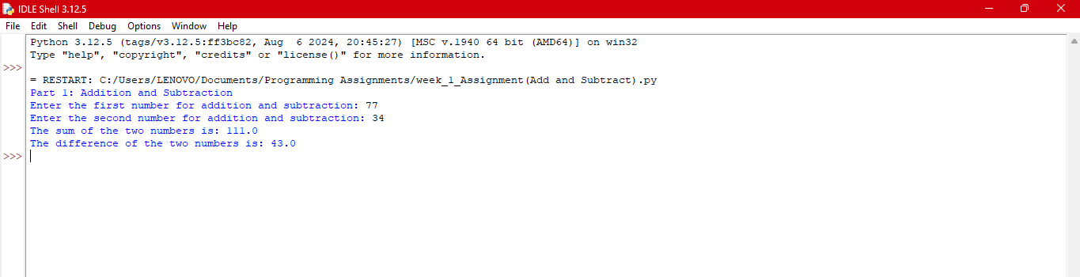

**Part 2: Multiplication and Division of Two Numbers**

**Pseudocode:**

1. Start

2. Prompt the user to input `num1_part2`

3. Prompt the user to input `num2_part2`

4. Multiply `num1_part2` and `num2_part2` and store the result in `product_result`

5. Divide `num1_part2` by `num2_part2` and store the result in `quotient_result`

6. If `num2_part2` is not 0, print the `quotient_result`

7. If `num2_part2` is 0, print "Division by zero is not allowed."

8. Print the `product_result`

9. End

**Source Code:**

# Part 2: Multiplication and Division

print(“Part 2: Multiplication and Division")

# Get user input for Part 2

num1_part2 = float(input("Enter the first number for multiplication and division: "))

num2_part2 = float(input("Enter the second number for multiplication and division: "))

# Multiplication

product_result = num1_part2 * num2_part2

# Division

if num2_part2 != 0:

division_result = num1_part2 / num2_part2

print("The division of the two numbers is:", division_result)

else:

print("Division by zero is not allowed.")

# Display the result

print("The product of the two numbers is:", product_result)

**Screenshot of Program Execution:**

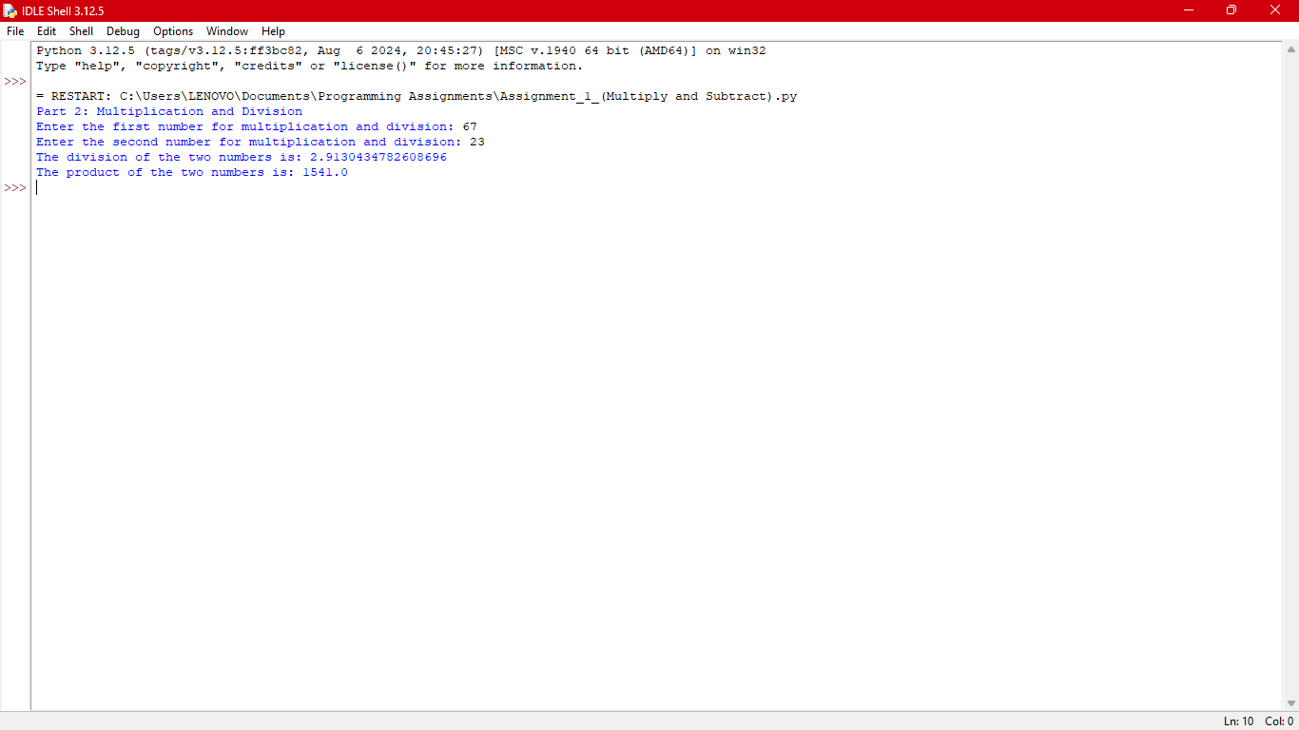

**GIT Repository Link:**